

REPORT TO: PERFORMANCE & AUDIT COMMITTEE – 25 SEPTEMER 2024

REPORT ON: DUNDEE HEALTH AND SOCIAL CARE PARTNERSHIP PERFORMANCE REPORT – 2023-24 QUARTER 4

REPORT BY: CHIEF FINANCE OFFICER

REPORT NO: PAC27-2024

1.0 PURPOSE OF REPORT

1.1 The purpose of this report is to update the Performance and Audit Committee on 2023-24 Quarter 4 performance against the National Health and Wellbeing Indicators and ‘Measuring Performance Under Integration’ indicators. Data is also provided in relation to Social Care – Demand for Care at Home services.

2.0 RECOMMENDATIONS

It is recommended that the Performance & Audit Committee (PAC):

2.1 Note the content of this summary report.

2.2 Note the performance of Dundee Health and Social Care Partnership, at both Dundee and Local Community Planning Partnership (LCPP) levels, against the National Health and Wellbeing Indicators as summarised in Appendix 1 (tables 1, 2 and 3).

2.3 Note the performance of Dundee Health and Social Care Partnership against the ‘Measuring Performance Under Integration’ indicators as summarised in Appendix 1 (table 3).

2.4 Note the number of people waiting for a social care assessment and care at home package and associated hours of care yet to be provided in Appendix 2.

3.0 FINANCIAL IMPLICATIONS

3.1 None.

4.0 BACKGROUND INFORMATION

4.1 The Quarterly Performance Report analyses performance against the National Health and Wellbeing Indicators. 5 of the 23 National Health and Wellbeing Indicators are monitored quarterly (emergency admissions, emergency bed days, readmissions, falls admissions and delayed discharge bed days lost). The quarterly performance report also summarises performance against indicators in the Measuring Performance Under Integration (MPUI) suite of indicators for four out of six high level service delivery areas – emergency admissions, emergency bed days, accident and emergency and delayed discharges, end of life and balance of care. Further information regarding these indicators and the methodology used to report these indicators can be found in Appendix 3.

4.2 The Public Bodies (Joint Working) (Scotland) Act 2014 and associated regulations and guidance prescribes that Partnerships must compare performance information between the current reporting year and the preceding five reporting years. From Q1 2023-24, quarterly performance reports use the 2018/19 baseline year for all indicators.

5.0 QUARTER 4 PERFORMANCE 2023-24 – KEY ANALYTICAL MESSAGES

5.1 Key analytical messages for the Quarter 4 2023-24 period are:

- Significant variation by Local Community Planning Partnership (LCPP) is still apparent, with poorest performance for many of the National Indicators in the most deprived LCPPs.

- Performance is poorer than the 2018-19 baseline for rate of emergency admissions 18+, rate of hospital admissions due to a fall 65+, emergency admission numbers from A+E 18+, emergency admissions as a rate of all A+E attendances 18+, 28 day readmissions rate, and rate of standard bed days lost to delayed discharges 75+.

- The rate of complex bed days lost to delayed discharges 75+ was 25% lower than the 2018-19 baseline which is an improvement.

- Rate of emergency bed days per 100,000 18+ population increased by 0.9% when compared with the 2018-19 baseline. 4 LCPPs saw a decrease in rate of emergency bed days (Coldside –1.6%, East End –3.2%, Lochee -9%, and Maryfield –13.4%).

- Rate of emergency admissions per 100,000 18+ population increased by 14% compared with the 2018-19 baseline and there was in increase across every LCPP. This is deterioration in performance.

- Rate of emergency readmission within 28 days of any admission increased by 9% between 2018-19 baseline and 2023-24. This is deterioration in performance. There was decrease (improvement) in 1 LCPP (East End by 6%).

- Rate of hospital admissions due to a fall increased by 20% between 2018-19 baseline and 2023-24. This is deterioration in performance. There was decrease (improvement) in 1 LCPP (Coldside by 12%).

- 90.7% of the last 6 months of life was spent at home or in a community setting; this is higher than the 2018-19 baseline of 89.1% (improvement). Although performance across Scotland is similar, Dundee is 5th best out of the 32 partnerships, 2nd in the family group (Local Government Benchmarking Framework).

- Rate of bed days lost to standard delayed discharge for people aged 75+ is 27% more than the 2018-19 baseline, which is a deterioration. However, there was an improvement in 4 LCPPs. At Q4 the LCPP with the highest rate (poorest) was West End (479 bed days lost per 1,000 people aged 75+) and the LCPP with the lowest (best) rate was North East (141 bed days lost per 1,000 people aged 75+). Report PAC28-2024 provides a more comprehensive overview and analysis of data and performance for delayed discharge within the Partnership.

- Rate of bed days lost to complex (code 9) delayed discharge for people aged 75+ decreased by 25% between the 2018-19 baseline and Q4 2023-24, which is an improvement. There were increases (deterioration) in 2 out of the 8 LCPPs. Increases were 103% in West End and 213% in East End. Report PAC28-2024 provides a more comprehensive overview and analysis of data and performance for delayed discharge within the Partnership.

5.2 Public Health Scotland publishes a report on the number of people who are waiting for Social Care and Care at Home service provided by the Health and Social Care Partnerships. The information, contained in Appendix 2, shows the number of people waiting for an assessment for a package of care to allow them to live at home or in the community and the number of hours of care that has been assessed but not yet delivered. The information is presented by people waiting in hospital or waiting at home / in the community for the care at home service to be delivered.

Data published from 15 January 2024 onwards reflect improved definitions and therefore caution should be taken when comparing with figures prior to this date.
In Dundee, as at 24 June 2024:

- 0 people waited in hospital and 119 people waited in the community for a social care assessment. 0 people have waited in hospital each week since 17 October 2022.

- 11 people were assessed and waiting for a care at home package in hospital (165 hours yet to be provided).

- 23 people were assessed and waiting for a care at home package in the community (135 hours yet to be provided).

- For those already in receipt of a care at home package 128 additional hours were required and not provided.

6.0 POLICY IMPLICATIONS

6.1 This report has been subject to the Pre-IIA Screening Tool and does not make any recommendations for change to strategy, policy, procedures, services or funding and so has not been subject to an Integrated Impact Assessment. An appropriate senior manager has reviewed and agreed with this assessment.

7.0 RISK ASSESSMENT

Risk 1  Description | Poor performance against national indicators could affect outcomes for individuals and their carers, spend associated with poor performance and the ability of the IJB to deliver fully commitments set out in the Strategic and Commissioning Plan.
Risk Category | Financial, Governance, Political
Inherent Risk Level | Likelihood 3 x Impact 5 = Risk Scoring 15 (which is an Extreme Risk Level)
Mitigating Actions (including timescales and resources ) | - Continue to develop a reporting framework which identifies performance against national and local indicators.  - Continue to report data quarterly to the PAC to highlight areas of exceptional performance (poor and excellent).  - Continue to support operational managers by providing in depth analysis regarding areas of poor performance, such as around readmissions to hospital and falls related hospital admissions.  - Continue to ensure that data informs operational practices and improvements and also that operational activities and priorities are used to interpret trends shown by the data.  - Work with operational managers to identify areas of poor performance that result in operational risk and undertake additional analysis as required.
Residual Risk Level | Likelihood 3 x Impact 3 = Risk Scoring 9 (which is a Moderate Level)
Planned Risk Level | Likelihood 2 x Impact 3 = Risk Scoring 6 (which is a Moderate Risk Level)
Approval recommendation | Given the moderate level of planned risk, this risk is deemed to be manageable.

8.0 CONSULTATIONS

8.1 The Chief Officer, Heads of Service, Health and Community Care and the Clerk were consulted in the preparation of this report.

9.0 BACKGROUND PAPERS

9.1 None.

Christine Jones  Acting Chief Finance Officer  Lynsey Webster  Lead Officer, Quality, Data and Intelligence  Shahida Naeem  Senior Officer, Data and Intelligence  Lisa Traynor  Assistant, Quality, Data and Intelligence | DATE: 28 August 2024
APPENDIX 1 – Performance Summary
Table 1: Performance in Dundee’s LCPPs - % change in Q4 2023-24 against baseline year 2018-19
Most Deprived Least Deprived LeastDeprived

National  Indicator | Dundee | Lochee | East End | Coldside | North East | Strathmartine | Mary field | West End | The Ferry
Emer Admissions rate per 100,000 18+ | +14% | +12.4% | +3.7% | +6.0% | +15.9% | +23.8% | +17.5% | +15.4% | +18.3%
Emer Bed Days rate per 100,000 18+ | +0.9% | -9.0% | -3.2% | -1.6% | +30% | +13.7% | -13.4% | +0.5% | +2.2%
28 Day Readmissions rate per 1,000 Admissions 18+ | +9% | +11% | -6% | +16% | +12% | +4% | +10% | +20% | +13%
Hospital admissions due to falls rate per 1,000 65+ | +20% | +93% | +11% | -12% | +66% | +8% | +54% | +2% | +9%
Delayed Discharge Bed Days Lost rate per 1,000 75+ (Standard) | +27% | -13% | -2% | +126% | -44% | -9% | +13% | +45% | +90%
Delayed Discharge Bed Days Lost rate per 1,000 75+ (Code 9) | -25% | -36% | +213% | -80% | -100% | -8% | -81% | +103% | -100%
Source: NHS Tayside BSU
Note: This table shows the Dundee position alongside the position for the 8 LCPPs. Where the LCPP position is poorer than Dundee this is coded as red (worse than Dundee) and where the LCPP position is better than Dundee this is coded as green.
Key: Improved/Better Stayed the same Declined/Worse

Table 2: Performance in Dundee’s LCPPs - LCPP Performance in Q4 2023-24 compared to Dundee
Most Deprived Least Deprived LeastDeprived

National  Indicator | Dundee | Lochee | East End | Coldside | North East | Strath martine | Mary field | West End | The Ferry
Emer Admissions rate per 100,000 18+ | 14,419 | 16,992 | 17,458 | 15,694 | 14,439 | 16,391 | 12,524 | 10,359 | 12,791
Emer Bed days rate per 100,000 18+ | 121,125 | 143,693 | 142,896 | 144,031 | 117,269 | 136,343 | 89,841 | 82,256 | 121,690
28 Day Readmissions rate per 1,000 Admissions 18+ | 153 | 156 | 154 | 149 | 146 | 159 | 164 | 159 | 134
Hospital admissions due to falls rate per 1,000 65+ | 36 | 49 | 36 | 35 | 31 | 32 | 39 | 37 | 33
Delayed Discharge bed days lost rate per 1,000 75+ (standard) | 353 | 391 | 302 | 474 | 141 | 204 | 295 | 479 | 390
Delayed Discharge bed days lost rate per 1,000 75+  (Code 9) | 69 | 93 | 266 | 43 | 0* | 83 | 28 | 30 | 24
Source: NHS Tayside BSU
Note: This table shows the Dundee position alongside the position for the 8 LCPPs. Where the LCPP position is poorer than Dundee this is coded as red (worse than Dundee) and where the LCPP position is better than Dundee this is coded as green.
*There have been no code 9 bed days lost for North East between April 23 to March 24. The last delays for this LCPP was in quarter 4 2022/23.
Key: Improved/Better Stayed the same Declined/Worse

Table 3: Performance in Dundee’s LCPPs - LCPP Performance in Q4 2023-24 compared to Dundee
Dundee = D | East End = EE | Coldside = C | West End = WE
Strathmartine = S | North East = NE | Lochee = L | The Ferry = TF
Indicators 1-9 are calculated from results of the National Health and Care Experience Survey. In order to only report responses of people who receive services from the Health and Social Care Partnerships, responses are filtered. The way in which these responses were filtered differed in 2017-18 and 2019-20, for all indicators except indicator 8 (carers) making the data incomparable. Health and Social Care Partnerships are required to monitor performance from the pre integration 2015-16 position to the current position or the previous five years. It is not possible for this to be done for Indicators 1-7 and 9 because; the survey is biennial and also because the methodology for filtering respondents was changed by the Scottish Government prior to the 2019-20 survey. The Scottish Government has advised that results should not be compared pre 2019-20, however, comparison can now be made for surveys years 2019-20, 2021-22 and 2023-24.

National Indicator | Difference From 18-19 Baseline | Dundee Short Term Trend (last 4 quarters) | Long Term Trend | Scotland Position  1= best, 31 = worst | Family Group Position  1= best, 8 = worst | Tayside Group Position  1= best, 3 = worst
1.% of adults able to look after their health very well or quite well* |  |  |  | 29th | 5th  (88%) | 3rd
2.% of adults supported at home who agreed that they are supported to live as independently as possible* |  |  |  | 10th | 3rd  (77%) | 1st
3.% of adults supported at home who agreed that they had a say in how their help, care, or support was provided* |  |  |  | 10th | 4th  (65%) | 2nd
4. % of adults supported at home who agree that their health and social care services seem to be well co-ordinated* |  |  |  | 13th | 4th  (64%) | 1st
5.% of adults receiving any care or support who rate it as excellent or good* |  |  |  | 22nd | 5th  (68%) | 2nd
6.% of people with positive experience of care at their GP practice* |  |  |  | 14th | 3rd  (71%) | 2nd
National Indicator | Difference From 18-19 Baseline | Dundee Short Term Trend (last 4 quarters) | Long Term Trend | Scotland Position  1= best, 31 = worst | Family Group Position  1= best, 8 = worst | Tayside Group Position 1= best, 3 = worst
7.% of adults supported at home who agree that their services and support had an impact on improving or maintaining their quality of life* |  |  |  | 14th | 3rd  (71%) | 2nd
8.% of carers who feel supported to continue in their caring role* |  |  |  | 8th | 3rd  (34%) | 1st
9.% of adults supported at home who agreed they felt safe* |  |  |  | 11th | 1st  (77%) | 2nd
10. % staff who say they would recommend their workplace as a good place to work | Not Available Nationally | Not Available Nationally | Not Available Nationally
11. Premature mortality rate per 100,000 persons | 4.5% less in 2022 than 2016 (improvement) | Not Available | 2022 is latest available published data | 29th | 6th | 3rd
National Indicator | Difference From 18/19 Baseline | Dundee Short Term Trend (last 4 quarters) | Long Term Trend | Scotland Position  1= best, 31 = worst | Family Group Position  1= best, 8 = worst | Tayside Group Position  1= best, 3 = worst
12. Emer Admissions rate per 100,000 18+ | There was an increase in the emergency admissions rate by 14% between 2018-19 and Q4 23-24. This equates to an increase of 2,042 emergency admissions (deterioration). (source: NHST BSU) | Increasing trend over the last 4 quarters. | Note - Linear (D) is the trendline for Dundee | 28th | 7th | 3rd
National Indicator | Difference From 18-19 Baseline | Dundee Short Term Trend (last 4 quarters) | Long Term Trend | Scotland Position  1= best, 31 = worst | Family Group Position  1= best, 8 = worst | Tayside Group Position  1= best, 3 = worst
Emergency Admissions Numbers from A&E (MSG) | 1013 more emergency admissions from A+E in Q4 23/24 than 2018/19. | An increase from last quarter. | Increase since 2020/21. | NA as number and not rate | NA as number and not rate | NA as number and not rate
Emergency Admissions as a Rate per 1,000 of all Accident &Emergency Attendances (MSG) | Rate is 42(14%) higher in 2023/24 than 2018/19. | An increase from last quarter. | Stable trend since 2021/22, despite emergency admissions numbers from A+E increasing. This is because the number of A+E attendances also increased albeit at a slower rate. | Not Avail | Not Avail | Not Avail
National Indicator | Difference From 18-19 Baseline | Dundee Short Term Trend (last 4 quarters) | Long Term Trend | Scotland Position  1= best, 31 = worst | Family Group Position  1= best, 8 = worst | Tayside Group Position 1= best, 3 = worst
Accident & Emergency Attendances (MSG) | 364 more A+E attendances in 2024 than 2018/19. | Increase in attendance from Q3 to Q4. |  | NA as number and not rate | NA as number and not rate | NA as number and not rate
13.Emer Bed days rate per 100,000 18+ | There was a slight increase in the emergency bed days rate by 0.9% between 2018-19 and Q4 23-24. This equates to an increase of 364 emergency bed days (deterioration). (source: NHST BSU)  4,283 (12%) less mental health bed days in Q3 2023-24 than 2018-19 (improvement) (source: MSG) | The emergency bed days rate increased between Q1 and Q2 with a significant decrease from Q2 to Q3 then to Q4.  *TrakCare data cleansing has taken place which has contributed to the Q3 decrease  A decrease in the rate of mental health emergency bed days since Q1 (improvement). | An overall decrease in the rate of mental health emergency bed days since 2018/19 (improvement). | 15th | 1st | 2nd
National Indicator | Difference From 18-19 Baseline | Dundee Short Term Trend (last 4 quarters) | Long Term Trend | Scotland Position  1= best, 31 = worst | Family Group Position  1= best, 8 = worst | Tayside Group Position 1= best, 3 = worst
14.Readmiss  ions rate per 1,000 Admissions 18+ | The rate is 9% higher at Q4 2023-24 than 2018-19. The number of readmissions (numerator) increased by 784 readmissions between 2018-19 and Q4 2023-24. | A progressive increase in the rate for readmissions over the last 4 quarters. (deterioration) |  | 31th | 8th | 3rd
15. % of last 6 months of life spent at home or in a community setting | Up from 88.8% in 2017/18 to 90.7% in 2023. (improvement) | Not Available. |  | 5th | 2nd | 2nd
16. Hospital admissions due to falls rate per 1,000 65+ | The rate of admissions has increased by 20% Q4 23-24 from the 2018-19 baseline. This equates to an increase of 168 fall related hospital admissions. The greatest increase (deterioration) in the number of falls was in Lochee with a 91% increase (79 fall related admissions) (deterioration). | Continuing increase in the rate of fall related admissions over the last 4 quarters. |  | 31st | 8th | 3rd
National Indicator | Difference From 18-19 Baseline | Dundee Short Term Trend (last 4 quarters) | Long Term Trend | Scotland Position  1= best, 31 = worst | Family Group Position  1= best, 8 = worst | Tayside Group Position 1= best, 3 = worst
18. % adults with intensive care needs receiving care at home | 7.4% (155 people) more in 2023 than 2017 (improvement) (note calendar year). | Not Available. | 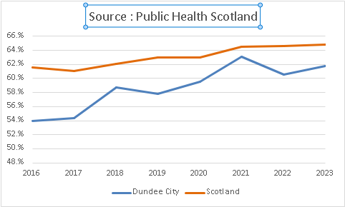 | 24th | 6th | 3rd
19.1 Delayed Discharge bed days lost rate per 1,000 75+ (standard) | 27% increase (deterioration) since 2018/19. | Improving trend in the last 2 quarters. |  | NA | NA | NA
National Indicator | Difference From 18-19 Baseline | Dundee Short Term Trend (last 4 quarters) | Long Term Trend | Scotland Position  1= best, 31 = worst | Family Group Position  1= best, 8 = worst | Tayside Group Position 1= best, 3 = worst
19.2 Delayed Discharge bed days lost rate per 1,000 75+ (Code 9) | 25% decrease (improvement) since 2018-19 and decrease (improvement) in 6 LCPPs. | Improvement between Q2 to Q4. |  | NA | NA | NA
Delayed Discharge bed days lost rate per 1,000 18+ (All Reasons) (MSG) | Bed days have almost doubled since 2019-20 (2018-19 data not provided by PHS). This is a deterioration.  In 2019-20 there were 9,861 bed days lost and this increased to 13,118 at Q4 2023-24. | Reduction (improvement) since Q1. | Overall increase since 2019-20. A decrease in the past year. | NA | NA | NA
National Indicator | Difference From 18-19 Baseline | Dundee Short Term Trend (last 4 quarters) | Long Term Trend | Scotland Position  1= best, 31 = worst | Family Group Position  1= best, 8 = worst | Tayside Group Position 1= best, 3 = worst
20. % of health and social care resource spent on hospital stays where the patient was admitted as an emergency | 5.8% less in 2020/21* than 2015/16 (improvement).  *latest data available | Not Available. |  | 18th | 3rd | 3rd

APPENDIX 2 SUMMARY OF SOCIAL CARE – DEMAND FOR CARE AT HOME SERVICES DUNDEE
This report is an assessment of the demand for Care at Home services provided by Health and Social Care Partnerships. The information shows the number of people waiting for an assessment for a package of care to allow them to live at home or in the community and the number of hours of care that has been assessed but not yet delivered. The information is presented by people waiting in hospital or waiting at home/community for the care at home service to be delivered.

The data items submitted from 15 January 2024 onwards reflect improved definitions and therefore comparability of figures before this date should be done with caution.

Chart 1
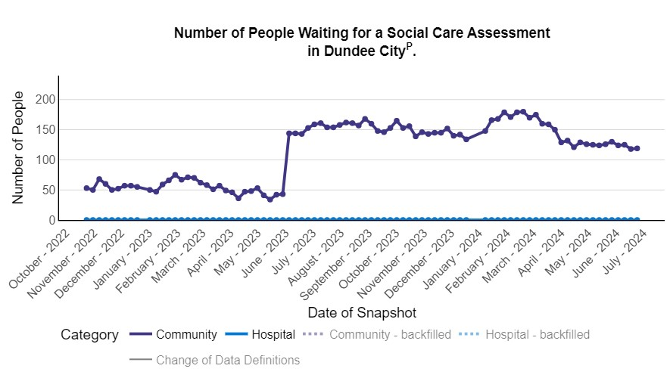

In Dundee as at 24 June 2024:
- 0 people waited in hospital and 119 people waited in the community for a social care assessment.
- 0 people have waited in hospital each week since 17 October 2022.

Chart 2
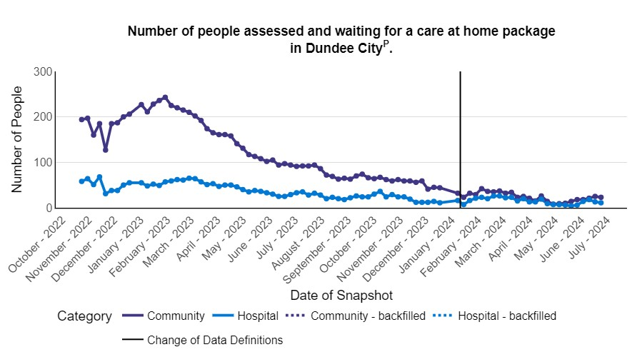
In Dundee as at 24 June 2024:
- 11 people were assessed and were waiting in hospital for a care at home package.
- 23 people were assessed and were waiting in the community for a care at home package.
Chart 3
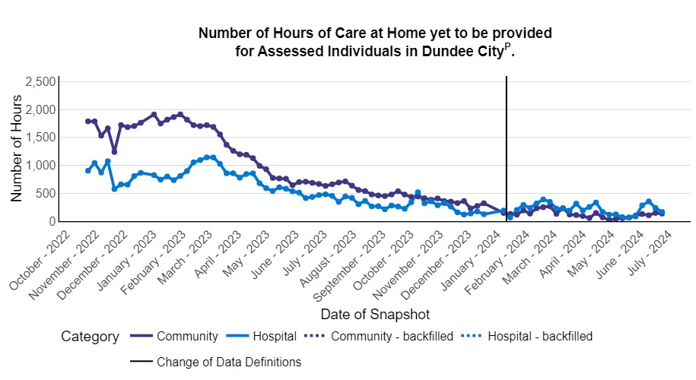

In Dundee as at 24 June 2024:

- 11 people were assessed and waiting for a care at home package in hospital (165 hours yet to be provided).
- 23people were assessed and waiting for a care at home package in the community (135 hours yet to be provided).

Chart 4

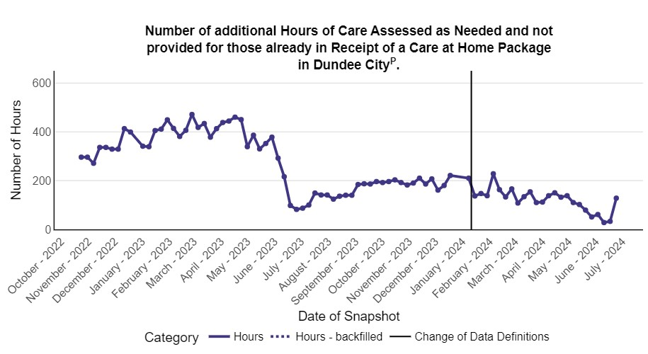

In Dundee as at 24 June 2024:

- For those already in receipt of a care at home package 128 additional hours were required and not provided.

APPENDIX 3 – DATA SOURCES USED FOR MEASURING PERFORMANCE

The Quarterly Performance Report analyses performance against National Health and Wellbeing Indicators 1-23 and Measuring Performance Under Integration (MPUI) indicators. 5 of the 23 National Health and Wellbeing Indicators are monitored quarterly (emergency admissions, emergency bed days, readmissions, falls admissions and delayed discharge bed days lost. Data is provided both at Dundee and Local Community Planning Partnership (LCPP) level (where available). Data is currently not available for eight out of the 13 National Indicators which are not reported using The Health and Social Care Experience Survey (see section 4.3). The Scottish Government and Public Health Scotland are working on the development of definitions and datasets to calculate these indicators nationally.

The National Health and Wellbeing Indicators 1-9 are reported from The Health and Social Care Experience Survey administered by the Scottish Government which is conducted biennially. Full details were provided to the PAC in February 2021 (Article V of the minute of the Dundee Performance and Audit Committee held on 3 February 2021 refers). The Scottish Government changed the methodology used to filter responses to reflect people who receive services from the Partnership and therefore it is not possible to longitudinally compare results for National Indicators 1-7 and 9.

The quarterly performance report also summarises performance against indicators in the Measuring Performance Under Integration (MPUI) suite of indicators for four out of six high level service delivery areas – emergency admissions, emergency bed days, accident and emergency and delayed discharges, end of life and balance of care. In November 2020 the Performance and Audit Committee agreed that targets should not be set for 2020/21 for these indicators, however that the indicators should continue to be monitored in quarterly performance reports submitted to the PAC (Article VI of the minute of the Dundee Performance and Audit Committee held on 24 November 2020 refers).

National data is provided to all partnerships, by Public Health Scotland. This data shows rolling monthly performance for emergency admissions, emergency admissions from accident and emergency, accident and emergency attendances, emergency bed days and delayed discharges. Previously Public Health Scotland were only able to provide data for all ages, however following feedback from Dundee and other Partnerships they have now provided data for people age 18+.

It was agreed at the PAC held on 19 July 2017 (Article VIII of the minute of the meeting refers) that local data, provided by the NHS Tayside Business Unit will be used to produce more timeous quarterly performance reports against the National Health and Wellbeing Indicators. NHS Tayside Business Unit has provided data for emergency admissions, emergency bed days, readmissions, delayed discharges and falls. From quarter 1 2020/21 the NHS Tayside Business Unit has been providing breakdowns of covid and non covid admission reasons for emergency admissions and emergency bed days.

Data provided by NHS Tayside differs from data provided by Public Health Scotland (PHS); the main differences being that NHS Tayside uses ‘board of treatment’ and PHS uses ‘board of residence’ and NHS Tayside uses an admissions based dataset whereas PHS uses a discharge based dataset (NHS Tayside records are more complete but less accurate as PHS data goes through a validation process). As PHS data is discharge based, numbers for one quarter will have been updated the following quarter as records get submitted for those admitted one quarter and discharged a subsequent quarter. By the time PHS release their data, records are (in most cases) 99% complete. The data provided by NHS Tayside Business Unit is provisional and figures should be treated with caution.

For Q4 the data is for the full financial year 1 April 2023 to 31 March 2024.

