

REPORT TO: PERFORMANCE & AUDIT COMMITTEE – 29 JANUARY 2025

REPORT ON: DRUG AND ALCOHOL SERVICES INDICATORS – 2024/25 QUARTER 2

REPORT BY: CHIEF FINANCE OFFICER

REPORT NO: PAC2-2025

1.0 PURPOSE OF REPORT

The purpose of this report is to update the Performance and Audit Committee on the performance of Drug and Alcohol Services.

2.0 RECOMMENDATIONS

It is recommended that the Performance & Audit Committee (PAC):

2.1 Note the data presented in this report, including the improvements in key indicators relating to access to drug treatment services during 2024/25 (section 6 and appendix 1).

2.2 Note the range of ongoing improvement activity (section 7).

3.0 FINANCIAL IMPLICATIONS

None.

4.0 BACKGROUND INFORMATION

4.1 Deprivation is high in Dundee, combined with one of the lowest employment rates and highest rates of people who are economically inactive in Scotland. Approximately 24,000 (25.5%) people in Dundee are recorded as economically inactive, this is 2% higher than the Scotland percentage of 23.5%. Health and wellbeing is known to vary by deprivation. Lifestyles that include smoking, unhealthy diet, the consumption of excess alcohol and recreational drugs are more prevalent in the most deprived localities. In general, people whose lifestyles include all or some of these factors have or will have poorer health and can experience a range of other risks to their wellbeing or safety.

4.2 Dundee has the second lowest life expectancy in Scotland. In Dundee life expectancy is 76.7 years, whereas it is 79.1 years in Scotland as a whole. Life expectancy varies substantially by deprivation level and the occurrence of morbidity including drug and alcohol use and mental illness. A significant proportion of the difference in life expectancy between Dundee and many other Partnerships can be accounted for by deaths at a young age from drugs, alcohol and suicide. Drug and alcohol use disproportionately affects the most vulnerable and socio-economically deprived people in Dundee’s communities and is associated with other health and social problems, including poor mental health, crime, domestic abuse and child neglect and abuse. Drug and alcohol use is recognised both at a national and local level as a major public health and health equity issue.

4.3 In Dundee City, drug and alcohol services are provided by a range of organisations, including the Dundee Drug and Alcohol Recovery Service (DDARS), offering a mixed-model approach delivered by a multidisciplinary team in collaboration with social work, community justice and third sector services. The aim of this service model is to offer the right care, in the right place, at the right time for every person. It consists of both drop-in and appointment-based services alongside an assertive outreach component and additional services for children, families and intensive input for expectant mothers. All elements of the service seek to provide same day access to treatment (Medication Assisted Treatment (MAT) Standard 1) and assertive outreach to those at the most risk of harm (MAT Standard 3).

5.0 DRUG AND ALCOHOL SUITE OF INDICATORS

5.1 The aim of this dataset is to provide oversight and assurance regarding activity and performance in drug and alcohol services. It contains a summary of data, alongside accompanying analytical narrative. In all data reports with public accessibility, content and disaggregation is assessed in order to comply with General Data Protection Regulation and ultimately to ensure that individuals cannot be identified.

5.2 Data for indicators 1 – 14 presents rolling averages for each quarter. This includes the reporting quarter plus the previous 3 quarters, to give an annual pattern based on the reporting quarter. For example, Q2 24/25 also includes data for Q1 24/25, Q4 23/24 and Q3 23/24. Reporting in this way allows for longitudinal comparison between the reporting quarter and previous years data.

6.0 WHAT THE DATA IS TELLING US

6.1 The number of suspected non-fatal overdose incidents reported by Scottish Ambulance Service and Police Scotland remained almost the same between Q2 2023/24 (201) and Q2 2024/25 (206).

6.2 The proportion of people who started treatment within 21 days of referral has remained high however decreased by 2% from 91% at Q2 2023/24 to 89% at Q2 24/25.

6.3 The number of referrals for alcohol treatment decreased from 616 at Q2 23/24 to 453 at Q2 24/25. There was an increase in the number of individuals starting alcohol treatment from 219 at Q2 2023/24 to 475 at Q2 2024/25. Statutory services are working to improve waiting times, and they have experienced above average numbers of people disengaging prior to treatment.

6.4 The number of referrals for drug treatment services increased from 546 at Q2 23/24 to 606 at Q2 24/25. The number of people starting drug treatment services decreased slightly during the same period (from 474 at Q2 2023/24 to 464 at Q2 2024/25)

6.5 The number of Alcohol Brief Interventions (ABIs) increased by 9% between Q2 23/24 (1210 ABIs) and Q2 2024/25 (1322).

6.6 The number of unplanned discharges where the service user disengaged increased by 42% between Q2 23/24 and Q2 24/25 (from 193 to 272).

6.7 In addition to the suite of indicators contained in appendix 1, the National Records of Scotland published their statistical report on drug-related deaths in Scotland in 2023 (report available in full at: Drug-related Deaths in Scotland in 2023 | National Records of Scotland (nrscotland.gov.uk)). In 2023 there were 1,272 deaths due to drug misuse in Scotland; this is 221 more deaths than in 2022. In 2023 in Dundee, there were a total of 46 deaths; this is an increase of 8 deaths in 2022. After adjusting for age, Dundee City had the second highest rate of drug misuse deaths in Scotland, behind Glasgow which has the highest rate (please note this is calculated over the five-year period 2019-2023).

6.8 The National Records of Scotland published their statistical report on deaths which are known to be a direct consequence of alcohol use. (report available in full at Alcohol-specific deaths 2023, Report) In 2023 there were 1,277 deaths which were a direct consequence of alcohol use in Scotland; this is 1 more death than in 2022. In 2023 in Dundee there were 36 deaths in 2023 which was a reduction of 1, compared with 2022 when it was reported to be 37. There was a peak during 2021 and 2022 when there were 43 and 46 deaths respectively. After adjusting for age, Dundee was in the top 3 in Scotland for alcohol-specific mortality rate and was higher than the Scottish average (the other areas in the top 3 were Glasgow City and North Lanarkshire.

7.0 SERVICE IMPROVEMENT AND PRIORITIES
7.1 During 2023-24 there was significant progress with the implementation of MAT standards 1-5, and good progress with the implementation of MATs 6-10. At the 2024 national benchmarking assessment, Dundee scored the maximum points possible (at this stage) for the implementation of all the 10 standards. The focus for the second quarter of 2024-25 was on maintaining the achievements made with the implementation of MAT standards, identifying and responding to gaps and expanding the implementation of the standards to all drugs and alcohol. Guidance from the national MAT Implementation Support Team on the extension of the standards is expected and in the meanwhile local plans for the extension of the standards to fit local needs are being implemented.
People in Dundee continue to have fast access to treatment, they have a choice as to the medication prescribed to them, with increasing numbers opting to receive Buvidal as their preferred medication and are supported to remain in treatment for as long as required. Independent Advocates (provided through DIAS and funded by the ADP) support individuals during the period they receive MAT and beyond. DDARS has established an assertive outreach team to support those at risk of disengagement from services.
Harm reduction support continues to be provided as part of the implementation of MAT, and during quarter 2 focused on increasing BBV and STI testing, as well as immunisation. The implementation of MAT standards is psychologically and trauma informed, with progress made to ensure the process follows a gendered approach. Frontline staff receive training to ensure they are skilled and supported to deliver the standards. The Multi-agency Consultation Hub (substance use and mental health) continues to progress and work is underway to establish this process as core business and ensure close links with other high risk review processes are established.
7.2 The Non-Fatal Overdose (NFOD) multi-agency rapid response team continues to meet on a daily basis and provide support to people who have experienced an overdose. There is now formal joint working with A&E with information provided by A&E to the NFOD Co-ordinator. During quarter 2 there has been a slight rise in the complexity of the needs of the people experiencing non-fatal overdoses, requiring the involvement of more services (in addition to the specialist substance use services). The three Tayside ADPs has jointly agreed to continue funding the Tayside NFOD co-ordinator until end March 2026.
7.3 There has been a significant increase in people from Dundee accessing residential rehab. All of these people are supported through the dedicated pathway to enter the residential treatment, during their stay and on their return to the community. More women have accessed residential rehabilitation than ever before, and most of those embarking on residential support completed the full treatment. Third sector partners continue to manage the residential rehabilitation pathway, preparing individuals prior to accessing the residential establishment, supporting them and their family during their time at the establishment and providing support back to the community.
7.4 The Drug Service Redesign Project continues to test ways of working to provide holistic shared care with general practice for those on Opioid Substitution Therapy (OST). Following a low uptake for this option, there was an increase of people opting for this option in 2023-24. During quarter 2 one more Primary Care practice joined the scheme. Community Pharmacies continue to be liaised with, to support their role and identify any additional support that they require. Key workers managed by the 3rd sector, as well as DDARS staff, continue to support participating GPs and other Primary Care staff to provide the care. Dundee Independent Advocacy Service (DIAS) are also key partners supporting this project.
Dundee received confirmation from the Scottish Government that the project can utilise the accrued underspend and extend for a further financial year. It is now planned that during the current financial year, the Career Start GP and the Project Nurses will continue their training. In the next financial year (2025-26), the project will aim to deliver its ambition of a Primary Care Team to support General Practices and the community pharmacies that are currently testing models, to continue exploring and improving models of care.
7.5 A short life group was established in response to reports of increased ketamine related harm in local areas. Through the group, there has been awareness raising amongst Primary Care colleagues across Tayside regarding possible clinical presentations that might indicate ketamine use and prompt enquiry. Opportunities for additional training of relevant staff are being explored with Scottish Drugs Forum, and the group is exploring options for school-based education around ketamine with a view to improving the consistency and impact of the messages. The group is also considering options for local work to explore young people's awareness of ketamine related risks and develop harm reduction messaging.
7.6 The Alcohol and Drug Partnership (ADP) has contracted additional support (managed by the third sector) to progress the development of non-opioid and alcohol pathways. Following a scoping process, models for both pathways have been developed and a series of tests of change are currently running to establish and implement best practice.
7.7 The ADP has commenced early discussions with the Scottish Government to explore options for developing a Safer Consumption Facility (SCF) in Dundee. An application to the Lord Advocate will be required, based on a needs assessment and other key evidence. There are several models for such a facility which need to be assessed, including an option for a mobile SCF.
8.0 RISK ASSESSMENT

Risk 1  Description | Risk of IJB not being sufficiently sighted on performance related to alcohol or drug services in Dundee.
Risk Category | Governance, Political
Inherent Risk Level | Likelihood 3 X Impact 3 = Risk Score 9 (High)
Mitigating Actions (including timescales and resources) | - Develop a dataset which will provide a suitable level of detail.  - Agree on the frequency of reporting.  - Liaise with the information and pharmacy colleagues in the ADP to ensure timeous reporting.  - Liaise with operational managers to inform analysis and contribute improvement information.
Residual Risk Level | Unlikely 2 x Minor 2 = Risk Score 4 (Moderate)
Planned Risk Level | Unlikely 2 x Minor 2 = Risk Score 4 (Moderate)
Approval recommendation | The PAC is recommended to accept the risk levels with the expectation that the mitigating actions are taken forward.

9.0 POLICY IMPLICATIONS

9.1 This report has been subject to the Pre-IIA Screening Tool and does not make any recommendations for change to strategy, policy, procedures, services or funding and so has not been subject to an Integrated Impact Assessment. An appropriate senior manager has reviewed and agreed with this assessment.

10.0 CONSULTATIONS

10.1 The Chief Officer, Heads of Service - Health and Community Care and the Clerk were consulted in the preparation of this report.

11.0 BACKGROUND PAPERS

None.

Christine Jones  Chief Finance Officer  Lynsey Webster  Lead Officer: Quality, Data and Intelligence  Shahida Naeem  Senior Officer, Quality, Data and Intelligence  Vered Hopkins  Lead Officer, Protecting People | DATE: 17 December 2024

Appendix 1
Drug and Alcohol Services Indicators – Q2 2024/25
Indicator | Rolling 21/22  Q4 | Rolling 22/23  Q1 | Rolling 22/23  Q2 |  | Rolling 22/23  Q3 | Rolling 22/23  Q4 | Rolling 23/24  Q1 | Rolling 23/24  Q2 | Rolling 23/24  Q3 | Rolling 23/24  Q4 | Rolling 24/25 Q1 | Rolling 24/25 Q2 |  | Comments/  Analysis
1. The number of suspected non- fatal overdose incidents reported by Scottish Ambulance Service (and Police) | 319 | 302 | 212 |  | 187 | 192 | 187 | 201 | 202 | 192 | 214 | 206 |  | No notable change in the last year  A new referral route of direct notification from Ninewells has been incorporated.
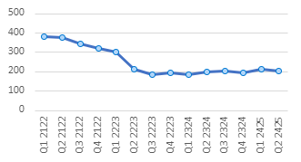

2. Percentage of people referred to services who begin treatment within 21 days of referral | 75.7% | 66.8% | 61% |  | 64% | 96% | 90% | 91% | 93% | 94% | 89% | 89% |  | The waiting time standard is 90%. Q4 23/24 - Q1 24/25 saw some waiting time delays and an analysis paper was presented to the ADP in August. Q2 24/25 was 97% so we expect this to return to above compliance.
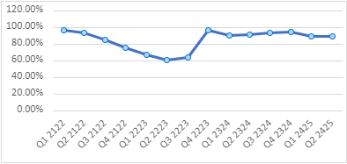
Indicator | Rolling  21/22  Q4 | Rolling 22/23  Q1 | Rolling 22/23  Q2 |  | Rolling 22/23  Q3 | Rolling 22/23  Q4 | Rolling 23/24  Q1 | Rolling 23/24  Q2 | Rolling 23/24  Q3 | Rolling 23/24 Q4 | Rolling 24/25 Q1 | Rolling 24/25 Q2 |  | Comments/Analysis
3. Number of referrals to alcohol treatment | 619 | 639 | 654 |  | 653 | 638 | 612 | 616 | 606 | 583 | 489 | 453 |  | Q1 24/25 was a large reduction in the number of referrals which rose again to expected levels in Q2.
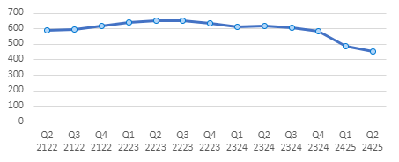

Indicator | Rolling  21/22  Q4 | Rolling 22/23  Q1 | Rolling 22/23  Q2 |  | Rolling 22/23  Q3 | Rolling 22/23  Q4 | Rolling 23/24  Q1 | Rolling 23/24  Q2 | Rolling 23/24  Q3 | Rolling 23/24  Q4 | Rolling 24/25 Q1 | Rolling 24/25 Q2 |  | Comments/Analysis
4. Number of individuals starting alcohol treatment per quarter | 430 | 435 | 437 |  | 583 | 638 | 638 | 519 | 493 | 535 | 505 | 475 |  | This is remaining low relative to the large numbers of treatment starts at the end of 22/23.
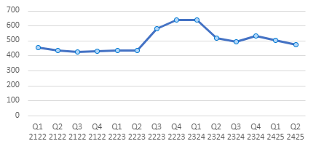

5. Number of referrals to drug treatment | 601 | 551 | 555 |  | 500 | 537 | 520 | 546 | 572 | 589 | 600 | 606 |  | There continues to be a steady number of new referrals.
￼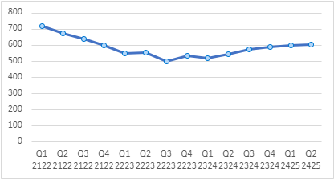
Indicator | Rolling  21/22  Q4 | Rolling 22/23  Q1 | Rolling 22/23  Q2 |  | Rolling 22/23  Q3 | Rolling 22/23  Q4 | Rolling 23/24  Q1 | Rolling 23/24  Q2 | Rolling 23/24  Q3 | Rolling 23/24  Q4 | Rolling 24/25 Q1 | Rolling 24/25 Q2 |  | Comments/Analysis
6. Number of individuals starting drug treatment per quarter | 294 | 265 | 384` |  | 366 | 399 | 412 | 474 | 432 | 491 | 485 | 464 |  | This is remaining relatively consistent.
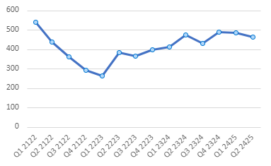
7. Number of alcohol brief interventions (ABI's) provided in Dundee | 727 | 1289 | 1459 |  | 1489 | 996 | 1087 | 1210 | 1434 | 1415 | 1500 | 1322 |  | There is an ongoing training programme for ABI’s.
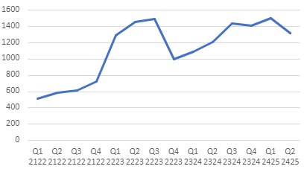
Indicator | Rolling  21/22  Q4 | Rolling 22/23  Q1 | Rolling 22/23  Q2 |  | Rolling 22/23  Q3 | Rolling 22/23  Q4 | Rolling 23/24  Q1 | Rolling 23/24  Q2 | Rolling 23/24  Q3 | Rolling 23/24  Q4 | Rolling 24/25 Q1 | Rolling 24/25 Q2 |  | Comments/Analysis
8. Number of unplanned discharges (service user disengaged) recorded in DAISY | 91 | 128 | 210 |  | 272 | 255 | 295 | 193 | 169 | 353 | 271 | 275
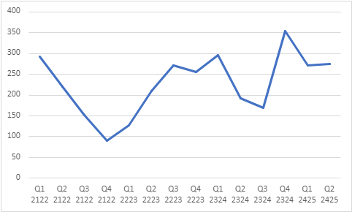

9. Number (rate per 1,000 18+ population) of emergency admissions where reason for admission was due to drug use |  | 466 (3.8) |  | 456 (3.8) | 438 (3.6) | 422 (3.5) | 462 (3.8) | 488 (4.0) | 472 (3.9) | 487  (4.0) | 461  (3.8) |  | 452  (3.7) |  | Stable trend
10. Number (rate per 1,000 18+ population) of emergency admissions where reason for admission was due to alcohol use |  | 356  (2.9) |  | 287  (2.4) | 260  (2.1) | 256  (2.1) | 260  (2.1) | 288  (2.4) | 282  (2.3) | 274  (2.3) | 274  (2.3) |  | 279  (2.3) |  | Stable trend
Indicator | Rolling  21/22  Q4 | Rolling 22/23  Q1 |  | Rolling 22/23  Q2 | Rolling 22/23  Q3 | Rolling 22/23  Q4 | Rolling 23/24  Q1 | Rolling 23/24  Q2 | Rolling 23/24  Q3 | Rolling 23/24  Q4 | Rolling 24/25  Q1 |  | Rolling 24/25  Q2
11. Naloxone Spend in Dundee | £67,417 | £64,098 |  | £70,622 | £80,675 | £77,134 | £82,549 | £68,927 | £55,818 | £43,240 | £35,343 |  | £42,886  An overpayment was identified which was refunded to DHSCP in February 2024.
12. Naloxone – Resupply Used | 195 | 353 |  | 388 | 398 | 410 | 323 | 293 | 268 | 255 | 243 |  | 238  All repeats have been consistently reported as it is accepted some may not disclose 'used' as the reason for repeat supply.
13. Total number of Naloxone Kits Issued | 1569 | 1944 |  | 1715 | 1602 | 1630 | 1528 | 1548 | 1456 | 1222 | 1303 |  | 1274  Naloxone kits supplied in Dundee (report from Tayside Take Home Naloxone Programme PHS submissions)  Naloxone spend does fluctuate across the year depending on when orders for stock are placed. Nyxoid intranasal kits were introduced around Q4 21/22 and a lot of services ordered stock of these kits for the first time, hence an increase in charges that quarter. There is a time lag for when we then see these kits appearing in supply figures.  First supplies are starting to decrease as saturation point is reached. This means replacement kits will start to increase and first supplies decrease. Kits last for 2 years so it is likely a dip in supply will be observed for a short period before starting to issue replacement kits.
Indicator | Rolling  21/22  Q4 | Rolling 22/23  Q1 |  | Rolling 22/23  Q2 | Rolling 22/23  Q3 | Rolling 22/23  Q4 | Rolling 23/24  Q1 | 23/24  Q2 (Not rolling) | 23/24  Q3 (Not Rolling) | 23/24  Q3 (Not Rolling) | Rolling 24/25 Q1 |  | Rolling 24/25 Q2
14. Total Spend on prescriptions generated by Dundee Drug and Alcohol Recovery Service (DDARS( and Dundee Drug Treatment Service (DDT) | £616,692 | £589,455 |  | £531,573 | £492,637 | £426,306 | Data for Q1 23/24 not available | £204,204.64 | £196,178.98 | £238,702.33 | Not available |  | Not available  Prescription data for prescriptions generated by DDARS and DTTO, dispensed in community pharmacy (report from prescribing support unit).  Please note that this data describes prescription costs for methadone and oral formulations of buprenorphine. DDARS now holds stock of Buvidal (long acting subcutaneous buprenorphine). The cost of this stock is not included in prescription data. The number of people choosing Buvidal as OST has increased.

